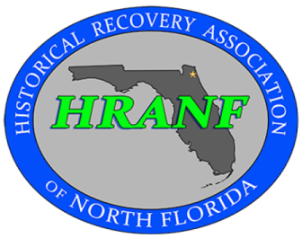
Historical Recovery Association of North Florida
Sign-In Sheet and Liability Waiver
In consideration of being allowed to participate in the following activity, I, the undersigned, intending to be legally bound, do hereby, for myself, my heirs, my personal representatives and assigns, waive, release and forever discharge any and all rights and claims for personal injury, property damage, causes of action, or claims of any kind arising from my participation in the activity described below which I may have or may accrue to m against Historical Recovery Association of North Florida, its officers, directors, organizers, sponsors, and participants. A parent or legal guardian must sign for participating minors
Activity: __________________________________________________ Date:_______________
Name (Print) Signature_
1)_______________________________________________________________________________
2)_______________________________________________________________________________
3)_______________________________________________________________________________
4)_______________________________________________________________________________
5)_______________________________________________________________________________
6)_______________________________________________________________________________
7)_______________________________________________________________________________
8)_______________________________________________________________________________
9)_______________________________________________________________________________
10______________________________________________________________________________
11______________________________________________________________________________
12______________________________________________________________________________
13______________________________________________________________________________
14______________________________________________________________________________
15______________________________________________________________________________
16______________________________________________________________________________
17______________________________________________________________________________

